**Problem definition**

We are building a system for both doctors and patients that combines medical scans (like X-rays or MRIs) with reports (like lab results or patient histories). For doctors, the system helps identify issues quickly, suggests possible diagnoses, and recommends treatment options. For patients, it provides simplified explanations of their condition and clear guidance for next steps. The AI analyzes medical images to detect patterns and reads reports for detailed context, combining both to give accurate and actionable insights. This can improve communication, speed up decisions, and make healthcare more effective for everyone while ensuring data remains secure and easy to understand

**Workflow: Integrating Imaging Data (CNN), NLP (Text to Tabular Conversion), and Generative AI for Insights**

This workflow demonstrates how imaging data, medical reports, and generative AI can be integrated to deliver actionable healthcare insights.

**1. Imaging Data Workflow (Using CNN Architecture)**

**Objective: Extract diagnostic insights from medical imaging data (e.g., X-rays, MRIs, CT scans).**

The objective of extracting diagnostic insights from medical imaging data involves analyzing scans like X-rays, MRIs, or CT images to identify abnormalities, assess severity, and guide clinical decisions. This process typically employs advanced convolutional neural networks (CNNs) for tasks such as anomaly detection (e.g., tumors, fractures) and segmentation of regions of interest (e.g., lung lesions). The workflow includes preprocessing steps like image normalization and enhancement, model training on medical datasets, and mapping outputs to standardized terminologies (e.g., ICD codes). Results provide actionable insights such as detected features and severity scores, aiding in faster, more accurate diagnoses for clinicians

**2. NLP Workflow (Converting Medical Reports into Tabular Format)**

**Objective: Transform unstructured medical reports into a standardized, machine-readable tabular format.**

The **NLP workflow** aims to transform unstructured medical reports into a standardized, machine-readable tabular format to facilitate data analysis and integration with imaging insights. Medical reports, often in free-text or semi-structured formats, contain valuable diagnostic information, but require processing to make them usable by AI models.

The process begins with **text preprocessing**, where noise is removed, abbreviations standardized, and the text is tokenized. Using **Named Entity Recognition (NER)**, the system identifies important entities like diagnoses, lab results, medications, and symptoms. These entities are then mapped to **standard medical vocabularies** (e.g., ICD, SNOMED) to ensure uniformity. For example, a lab result like "HbA1c = 7.5%" will be classified under a specific test name and value, while medical conditions like "diabetes" will be labeled with the corresponding ICD code.

After extraction, the data is organized into a **tabular format**, making it easier to integrate with imaging data and AI models. This structured data includes fields such as test results, diagnosis, medication, and severity. The NLP process enables healthcare systems to efficiently analyze patient histories and lab reports alongside medical imaging data, allowing AI models to generate more accurate diagnostic insights and treatment recommendations, improving decision-making for both doctors and patients.

**3. Generative AI Workflow (Combining Data for Insights)**

**Objective: Combine imaging and tabular data to generate comprehensive insights and recommendations.**

The **Generative AI workflow** focuses on integrating imaging data (e.g., X-rays, CT scans) with structured data from medical reports to generate comprehensive insights and actionable recommendations. The process begins by **combining features** from both modalities. Imaging data, processed using Convolutional Neural Networks (CNNs), provides insights like detected anomalies, while **NLP-generated tabular data** from patient reports (e.g., diagnoses, lab results) offers context and additional details.

Once integrated, this multimodal data is fed into a **generative AI model** (e.g., GPT, BERT) trained on clinical data. The AI model analyses the combined information and generates insights such as **differential diagnoses**, **risk stratifications**, and **treatment suggestions**. For example, based on an imaging report showing a lung lesion and a history of chronic cough, the AI might suggest **tuberculosis** as a likely diagnosis and recommend a sputum test for confirmation.

The model can also produce **patient-friendly summaries**, simplifying complex medical jargon into clear guidance, such as, “Your symptoms and test results suggest a lung infection. Your doctor may recommend further tests.”

By combining imaging and report data, the generative AI provides **actionable insights** that support doctors in making faster, more accurate decisions and help patients better understand their conditions, improving healthcare delivery and patient outcomes.

**End-to-End Flow Example**

1. **Imaging**: A chest X-ray reveals a possible lung lesion, and the CNN flags it as suspicious with a 92% confidence level.
2. **NLP**: Patient history mentions chronic cough and recent weight loss; lab results indicate elevated white blood cell counts.
3. **Generative AI**:
   * Combines findings to suggest: **"Likely diagnosis: tuberculosis. Recommended actions: sputum test, antibiotic therapy."**
   * Generates a patient-friendly summary: **"Your symptoms and test results suggest a lung infection. Your doctor may recommend further tests to confirm and start treatment."**

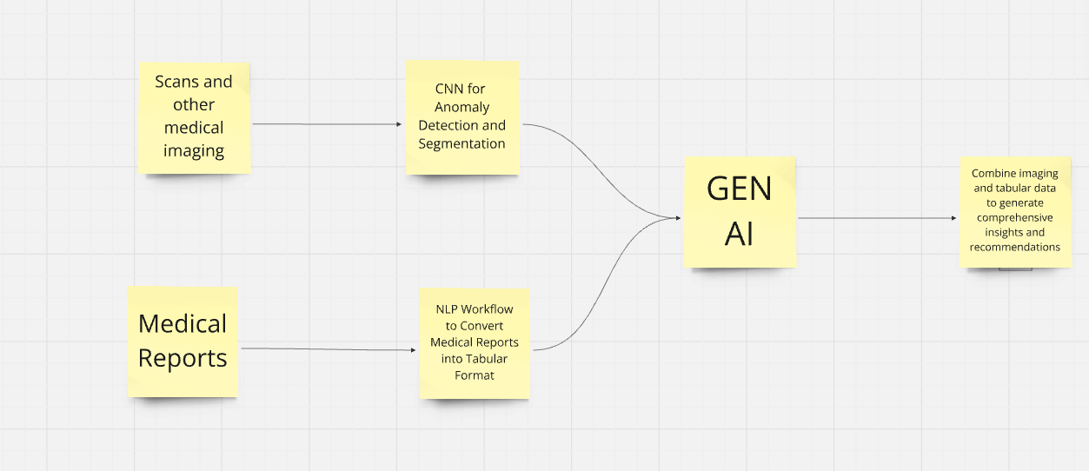

**2. Benefits for Patients**

* **Simplified, Actionable Recommendations**: The generative AI models simplify complex medical findings into **layman’s terms**. For instance, a diagnosis of “pulmonary embolism” might be simplified to “a blood clot in your lungs” with an explanation of necessary steps, such as medication or follow-up tests. This reduces patient anxiety and confusion, providing them with clear and **actionable next steps**.
* **Improved Understanding of Health Conditions**: By generating **patient-friendly summaries**, patients gain a deeper understanding of their health. This enables them to better grasp their condition, treatment options, and the reasoning behind certain medical decisions. Such clarity helps patients feel more empowered in managing their health, leading to better **compliance with prescribed treatments** and overall **improved health outcomes**.